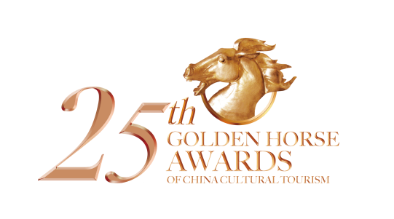

**2024-2025年度**

**第二十五届中国文旅金马奖参评表（企业／机构奖）**

The 25th Golden Horse Awards of China Cultural and Tourism Application Form

(For Enterprises and Institutes)

|  |  |  |  |
| --- | --- | --- | --- |
| 单位名称  Company Name | 中文： | | |
| ENG： | | |
| 参评奖项  Award Name |  | | |
| 法人代表  Legal  Representative |  | 单位性质  Company Type |  |
| 单位官网  Home Page |  | 微信公众号  Enterprises Official We Chat |  |
| 联系人  Contacts |  | 职务  Position |  |
| 手机  Mobile |  | 微信号  We Chat |  |
| 电子邮箱  E-mail |  | 电话  Telephone |  |
| 通讯地址  Add |  | | |
| 企业简介  （如有需要，请另附纸张详述）  Enterprise Introduction |  | | |
| 单位意见  Unit Opinion | （盖章/Seal）  年/Y 月/M /D | 评审委员会意见  Recommended Opinions | （盖章/Seal）  年/Y 月/M 日/D |

填表日期 /Date： 年 /Y 月 /M 日 /D 档案号 /Number：

**第二十五届中国文旅金马奖参评材料**

**参评企业／机构奖项：**

①完整填写“企业／机构奖”参评表格，提供营业执照副本证复印件（复印件上加盖红色公

章，必须有当年的年检章）；

②参评企业宣传资料一套、LOGO（AI 格式）；

③文旅项目提供鸟瞰图/全景图，景点、娱乐设施等照片共10张（JPG格式，精度要求300dpi

或以上）；酒店/公寓/民宿提供外观、大堂、客房、餐厅、配套设施等照片共10张（JPG格

式，精度要求300dpi或以上）；餐饮企业提供外观、大厅、包间等照片共5张（JPG格式，

精度要求300dpi或以上）；供应商、服务商、设计机构等提供企业形象照片、代表作品或主打

产品照片5张（JPG格式，精度要求300dpi或以上）；

④1000 字以内企业介绍；

## The 25th Golden Horse Awards of China Cultural and Tourism

## Application Materials

**For Enterprises/Institutes Awards**

1.Complete “2024-2025 annual enterprise/agencies award” application form, and provide the duplicate of business license, which shall be officially sealed in red, with the certificate of annual inspection required.

2.Contestant enterprises shall provide publicity materials and logo (ai).

3.Culture tourism companies shall provide 10 photos in total (Jpg, more than 300dpi) of aerial view/panoramic view of attractions,entertainment facilities,etc.

Hospitality industry shall provide 10 photos in total (Jpg, more than 300dpi) of the exterior appearance, lobby, guestroom, restaurant, supporting facilities.

Catering enterprises shall provide 5 photos in total (Jpg, more than 300dpi) of the exterior appearance, hall, and private room.

Suppliers and design institutions shall provide 5 photos in total (Jpg, more than 300dpi) of enterprise image, representative works and flagship products.

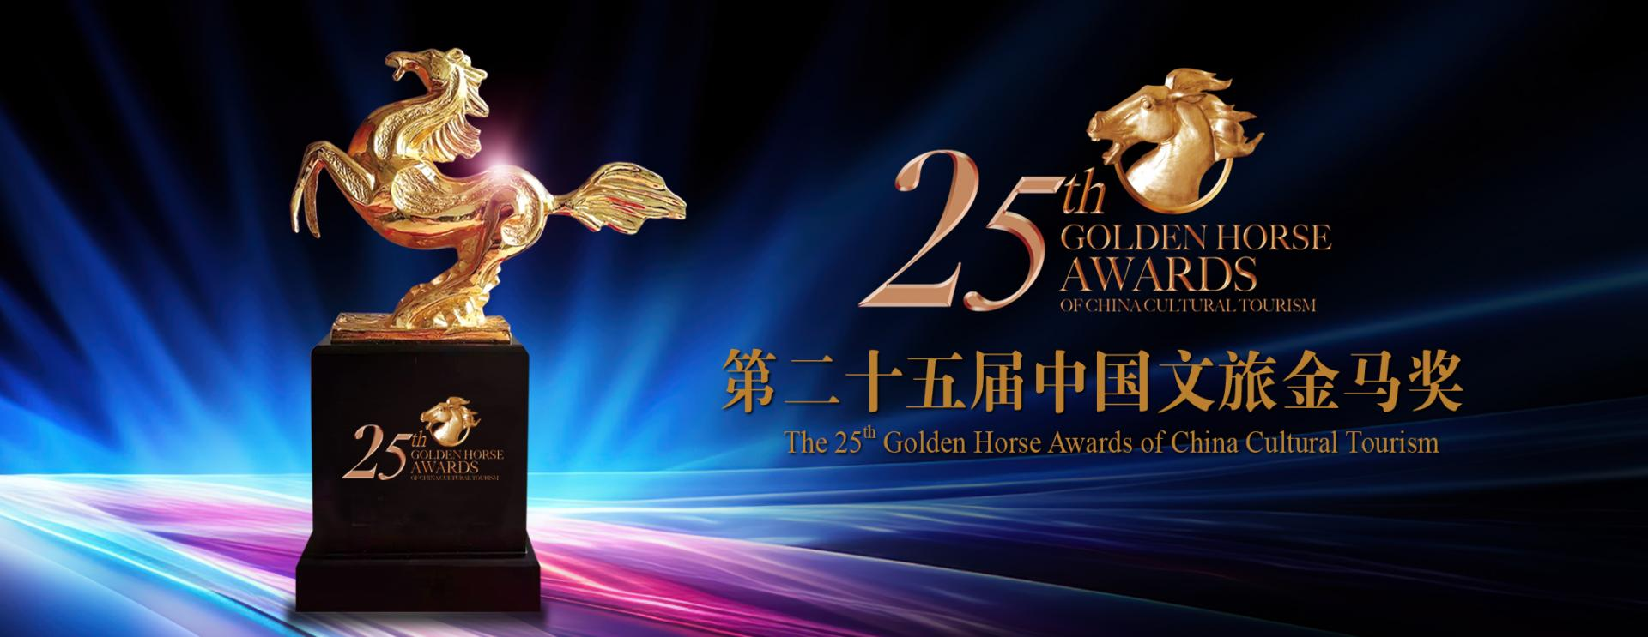4.An introduction within 1000 words in both english and chinese is required.